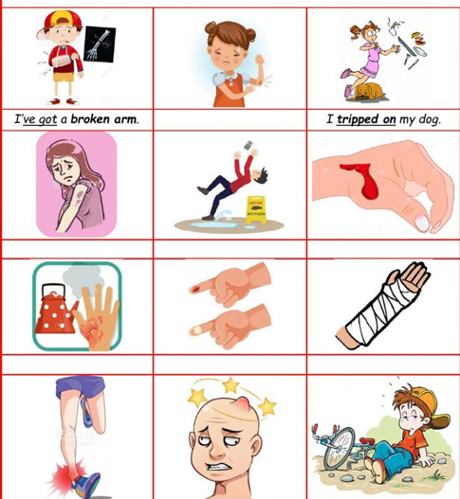
COMMON HOME ACCIDENTS

